***Audit Manager Authority***

**Revision: 1.0**

|  |  |  |  |
| --- | --- | --- | --- |
| Date | Revision | Author | Description |
| 2021/02/20 | 1.0 | Lena Liu | Initial creation from BNPP request |
|  |  |  |  |
|  |  |  |  |
|  |  |  |  |

**Eaton**

[www.eaton.com/powerquality](http://www.eaton.com/powerquality)

LEGAL NOTICE

Copyright © 2020. Eaton. All rights reserved. The contents of this document constitute valuable proprietary and confidential property of Eaton Corporation and are provided subject to specific obligations of confidentiality set forth in one or more binding legal agreements. Any use of this material is limited strictly to the uses specifically authorized in the applicable license agreement(s) pursuant to which such material has been furnished. Any use or disclosure of all or any part of this material not specifically authorized in writing by Eaton Corporation is strictly prohibited.

**Contact Eaton Support**

For your convenience, Eaton provides support to assist you with questions on installation, operation and troubleshooting. Please contact us at:

[softwareconnectivityts@eaton.com](mailto:softwareconnectivityts@eaton.com)

800-356-5737 option 2, option 5, option 1

# Contents

Contents 3

1. Overview 4

2. Design 5

# Overview

**Audit Status & Actions:**

|  |  |
| --- | --- |
| Audit Status | Actions |
| Not Started | **Modify Audit**   1. Name 2. Cable types required to audit 3. Add/Remove racks required to audit   **Delete Audit** |
| In Progress | **Cancel Audit**  **Modify Audit Name** |
| Canceled | **Modify Audit Name** |
| Completed | **Modify Audit Name** |
| Incomplete - Error | **Modify Audit Name** |
| Completed With Error | **Modify Audit Name** |

**Audit Manager Authority:**

Only administrators can access Audit Manager and manage audits before 6.4.1.

This design document is to fix the following issue reported by BNPP:

***The Audit Manager Menu item is incorrectly restricted to “administrator” group***

# Design

Requirements:

There are 2 authorisations required - view and edit.

1. A user with *Edit* Audit authority (create, update, delete) can manage audits for any rack within their scope of view, that is they can only add or delete racks that thy can “view”.
2. A user with *View* Audit authority can view all audits and view the list of racks in the audit in their scope. However, I suggest a message is required to say that they are viewing x out of y racks.

**User Groups Changes**:

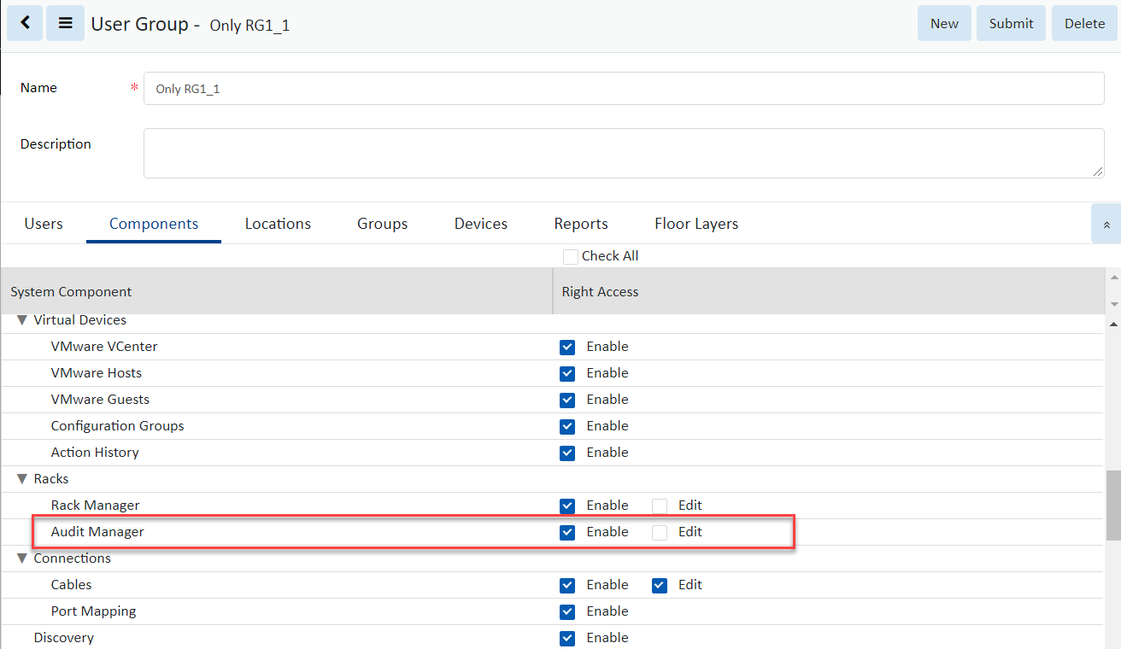

**View Only Case:**

A user with View Audit authority, the New, Delete and Cancel buttons are disabled.

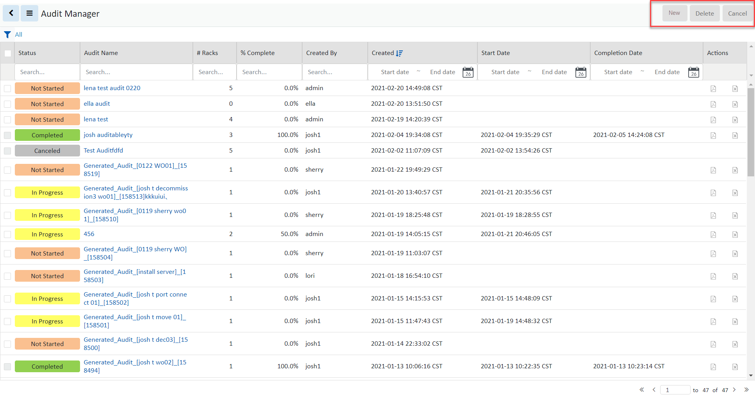

If the user doesn't have rights access to all racks in an audit, when he opens the audit details page, the racks list shows with the following message pop:

You are viewing {x} out of {y} racks.

And all fields cannot be modified. The New, Submit and Delete buttons are disabled. The Add and Remove racks buttons are disabled.

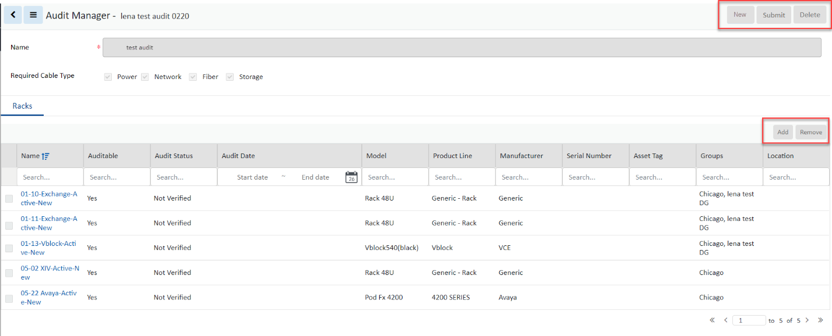

When exporting an audit, only racks which the user has view right access will be exported

For Rackmount Assets, only those the user has view right access will be exported, regardless right access of the container of those Rackmount Assets

For Cables, if a cable can be exported depends on if the user has view access to both the provider and consumer devices

